DEPARTMENT OF COMPUTER SCIENCE AND ENGINEERING
CSA1203 – Computer Architecture

Design and Analysis of an Energy-Efficient Processor
and Hierarchical Memory System
Assignment 1 — Full Report

Field | Details
Course Code & Name | CSA1203 – Computer Architecture
Course Outcomes Covered | CO1, CO3, CO4
Bloom's Taxonomy Level | L3 – Apply ; L4 – Analyze
SDG Mapping | SDG 7 (Affordable & Clean Energy), SDG 9 (Industry, Innovation & Infrastructure), SDG 12 (Responsible Consumption & Production)
Student Name | Siva Balan K
Register / Roll Number | 192572037
Date of Submission | 01/09/2026

Problem Statement
A smart manufacturing company plans to develop an energy-efficient processor for an industrial monitoring system. The processor must efficiently handle continuous sensor data streams and real-time control/actuation requirements while minimising power consumption. This report analyses the required functional units, instruction execution flow, pipelined datapath, hazard-handling strategy, and hierarchical memory system, and proposes an optimised processor and memory organisation supporting the target SDGs.

1. Functional Units, Instruction Execution, Addressing Modes & Performance Analysis

1.1 System Architecture — Functional Units
The industrial monitoring processor is organised around five functional blocks connected by a shared system bus, as shown in Figure 1.
CPU  ALU + Control Unit + Register File | Cache (L1/L2/L3)  On-chip hierarchy | Main Memory  DRAM | Secondary Storage  NAND Flash
SYSTEM BUS (Address / Data / Control)
I/O Controller  DMA + Interrupt Ctrl | Sensor Interface  ADC / Digital I/O | Actuator Interface  PWM / Control Out | Comm. Module  UART / CAN / Ethernet
Figure 1: Functional-unit block diagram of the proposed industrial monitoring processor

Component Roles
Unit | Function | Design Consideration
CPU (ALU + CU + Registers) | Executes arithmetic/logic operations, controls instruction flow, holds operands | Low-power in-order 5-stage RISC core with clock gating
Cache Hierarchy (L1/L2/L3) | Reduces average memory access latency | Split L1 I/D cache; unified L2/L3 (see Section 3)
Main Memory (DRAM) | Stores program and sensor-data buffers | Low-power DDR with self-refresh mode
Secondary Storage (NAND Flash) | Non-volatile event/data logging | Wear-levelled flash controller
I/O Controller (DMA + Interrupts) | Moves sensor data without CPU intervention; services interrupts | Burst-mode DMA to cut CPU wake-ups
System Bus | Shared address/data/control path between all units | Split-transaction bus to reduce structural stalls

1.2 Instruction Execution Cycle
Every instruction in the processor follows the classic fetch–decode–execute cycle, extended here into five discrete stages that map directly onto the pipeline discussed in Section 2:
- Instruction Fetch (IF): Instruction is read from I-cache using the Program Counter (PC); PC is incremented.
- Instruction Decode (ID): Opcode and operands are decoded; register file is read; control signals generated.
- Execute (EX): ALU performs the arithmetic/logic operation, computes branch targets, or calculates effective memory addresses.
- Memory Access (MEM): Load/store instructions access D-cache; other instructions pass through unchanged.
- Write Back (WB): Result is written back into the register file.
Example — reading a sensor threshold comparison instruction "CMP R1, R2" followed by a conditional branch: IF fetches CMP, ID reads R1/R2, EX computes R1−R2 and sets condition flags, MEM is unused, WB updates the flags register.

1.3 Addressing Modes Used
Addressing Mode | Example | Typical Use in this System
Immediate | MOV R1, #75 | Loading a fixed sensor threshold (e.g., 75°C alarm limit)
Register | ADD R3, R1, R2 | Fast ALU operations on values already in registers
Direct (Absolute) | LOAD R4, [0x2000] | Reading a memory-mapped I/O status register
Register Indirect | LOAD R5, [R6] | Accessing a sensor buffer via a pointer register
Indexed | LOAD R7, [R8 + R9] | Walking through an array of periodic sensor samples
Base + Displacement | LOAD R10, 12(R11) | Accessing a specific field inside a sensor-data structure

1.4 Performance Analysis — CPI, Clock Cycles, Execution Time
Assume a target clock rate of 1.2 GHz and the following instruction mix, obtained by profiling a representative industrial-monitoring workload (sampling sensors, filtering, threshold checks, and actuation):
Instruction Class | Frequency | Cycles per Instruction (CPI) | Weighted CPI Contribution
ALU / Logic | 45% | 1 | 0.45
Load / Store | 25% | 3 | 0.75
Branch | 15% | 2 | 0.30
Sensor I/O | 10% | 4 | 0.40
Multiply / Divide | 5% | 5 | 0.25

Average CPI:
CPI = Σ (Frequency_i × CPI_i) = 0.45+0.75+0.30+0.40+0.25 = 2.15 cycles/instruction
Clock cycle time:
T_clk = 1 / 1.2 GHz = 0.833 ns
Execution time for a program of 1,000,000 (10⁶) instructions:
Execution Time = Instruction Count × CPI × T_clk
= 10⁶ × 2.15 × 0.833 ns ≈ 1.791 × 10⁶ ns ≈ 1.79 ms
Processor throughput (MIPS):
MIPS = Clock Rate (MHz) / (CPI × 10⁶) = 1200 / 2.15 ≈ 558 MIPS
Benchmarking note: For an embedded industrial controller, EEMBC AutoBench / CoreMark-style kernels (filtering, control loops, checksum) are more representative than SPEC CPU, since they mirror sensor-processing and control-loop behaviour rather than general desktop workloads. Reported CoreMark/MHz is therefore used, in addition to raw MIPS, as the benchmarking figure of merit for this design.

2. Pipelined Processor Organization & Hazard Analysis

2.1 Pipelined Datapath
A 5-stage in-order pipeline (IF – ID – EX – MEM – WB) is adopted to raise instruction throughput without a large area/power penalty, matching the CPI targets above. Table 2 traces four instructions through the pipeline, showing a data hazard (I2, I3 depend on I1) and a control hazard (I4, a branch).
Instruction | T1 | T2 | T3 | T4 | T5 | T6 | T7
I1: LOAD R1,[R2] | IF | ID | EX | MEM | WB
I2: ADD R3,R1,R4 |  | IF | ID* | EX | MEM | WB
I3: SUB R5,R3,R6 |  |  | IF | ID* | EX | MEM | WB
I4: BR Loop |  |  |  | IF | (stall) | IF' | ID
Table: Pipeline execution trace (ID* = decode stalled/forwarded due to hazard; IF' = re-fetch after branch resolution)

2.2 Hazard Types Identified
Hazard Type | Cause in this Design | Example
Structural Hazard | A single unified memory port is shared by the IF stage (instruction fetch) and the MEM stage (data access) in the same cycle | I1 in MEM and a later instruction's IF collide on the shared cache port
Data Hazard (RAW) | An instruction needs a register value that a previous, still-in-flight instruction has not yet written back | I2 (ADD R3,R1,R4) needs R1 loaded by I1 (LOAD R1,[R2]) two cycles earlier
Control Hazard | The next instruction to fetch is unknown until a branch is resolved in EX | I4 (BR Loop) — instructions after it cannot be safely fetched until the branch outcome is known

2.3 Hazard-Mitigation Techniques Applied
- Forwarding / Bypassing: The EX/MEM and MEM/WB pipeline registers feed results directly back to the EX stage input, so I2 can use I1's loaded value the cycle it becomes available instead of waiting for WB — this removes most RAW stalls for ALU-to-ALU dependencies.
- Stalling (Pipeline Interlock): When a load result is needed by the immediately following instruction (load-use hazard), a single bubble is inserted, since a plain load cannot be forwarded one cycle early.
- Structural resolution: Split I-cache and D-cache ports remove the fetch/memory-access bus conflict entirely, converting the structural hazard into a non-issue for the common case.
- Branch Prediction: A 2-bit saturating-counter dynamic predictor is used for the frequent threshold-check branches in the sensor-monitoring loop; on misprediction the 2 fetched instructions are squashed and the pipeline restarts from the correct target (as shown by IF' in the trace).

2.4 Superscalar, Out-of-Order and Speculative Execution — Comparison
Technique | Principle | Benefit for this Workload | Cost / Risk
Superscalar (2-way) | Fetch/decode/issue ≥2 instructions per cycle to duplicated execution units | Exploits independent ALU + load/store pairs common in filtering code | Extra hardware (decoders, issue logic); diminishing returns if ILP is low
Out-of-Order Execution | Instructions issue as soon as operands are ready, not strictly in program order, using a reorder buffer | Hides load latency from sensor buffers behind independent ALU work | Complex scheduling logic, larger register file, higher power — a concern for an energy-constrained design
Speculative Execution | Predicted branch path is executed before the branch resolves; results committed only if correct | Keeps the pipeline full across the frequent conditional threshold checks | Wasted energy on squashed instructions; requires safe rollback for I/O side-effects

2.5 Suitability of Simultaneous Multithreading (SMT)
The industrial monitoring workload is characterised by frequent, short waits for sensor I/O and memory (DMA transfers, ADC conversions), during which a single-threaded pipeline sits idle. SMT allows a second hardware thread (e.g., a diagnostics/logging task) to issue instructions into the otherwise-empty pipeline slots during these stalls, raising functional-unit utilisation without duplicating the full core. Given the design's power budget, 2-way SMT is recommended rather than deep out-of-order plus 4-way SMT: it captures most of the latency-hiding benefit for I/O-bound stalls at a much smaller area/power cost, which better matches the CO3 goal of "improving processor utilisation" under the energy constraints of Section 4.

3. Hierarchical Memory System & Performance Evaluation

3.1 Cache Hierarchy Design
Level | Type / Size | Access Latency | Local Hit Rate | Role
L1 (I + D, split) | 32 KB each, 4-way | 1 cycle | 95% | Serve the tight sensor-sampling / control loop instructions and hot data
L2 (unified) | 256 KB, 8-way | 10 cycles | 90% (of L1 misses) | Buffer larger filter windows and multi-sensor working sets
L3 (shared) | 2 MB, 16-way | 30 cycles | 98% (of L2 misses) | Shared across cores/threads (incl. SMT) to cut off-chip traffic
Main Memory (DRAM) | 512 MB – 1 GB | 100 cycles | — | Program image, large sensor-history buffers

3.2 Average Memory Access Time (AMAT)
AMAT = HitTime_L1 + MissRate_L1 × ( HitTime_L2 + MissRate_L2 × ( HitTime_L3 + MissRate_L3 × Time_Mem ) )
Substituting the values from Table above (miss rate = 1 − hit rate):
AMAT = 1 + 0.05 × ( 10 + 0.10 × ( 30 + 0.02 × 100 ) )
= 1 + 0.05 × ( 10 + 0.10 × 32 )
= 1 + 0.05 × ( 10 + 3.2 ) = 1 + 0.05 × 13.2
AMAT ≈ 1.66 cycles
At 1.2 GHz this corresponds to roughly 1.38 ns average memory access time — well within the latency budget needed to keep the 5-stage pipeline's MEM stage from stalling on the common case, since 95% of accesses resolve in a single cycle at L1.

3.3 Virtual Memory with Paging
- Page size: 4 KB, mapped through a 2-level page table to keep page-table memory overhead small on an embedded budget.
- TLB: 64-entry, fully associative, translating the hot working set (sensor buffers, control-loop code) in parallel with the L1 access to avoid adding translation latency to the common case.
- Protection: Paging isolates the real-time control tasks from lower-priority logging/diagnostic tasks (relevant if SMT runs a second thread), preventing a runaway logging routine from corrupting control-loop memory.
- Page faults: Handled by a lightweight fault handler; since real-time deadlines matter, critical control-loop pages are pinned (non-swappable) while logging/history buffers may be paged to flash.

3.4 Memory Technology Comparison
Technology | Latency | Bandwidth | Volatility | Endurance | Power | Best Role Here
SRAM | Sub-ns – ~1 cycle | Very High | Volatile | Unlimited | Low static, high density-cost | L1/L2/L3 cache cells
DRAM | ~50–100 cycles | High | Volatile (needs refresh) | Unlimited | Moderate (refresh power) | Main memory
NAND Flash | µs-level (block) | Moderate | Non-volatile | ~10⁴–10⁵ writes/cell | Low (idle), higher on write | Event/data logging, firmware storage
MRAM | ~10s of ns | Moderate–High | Non-volatile | Very high (~10¹²) | Very low standby, no refresh | Non-volatile buffer for critical sensor state (survives power loss)
RRAM | ~10s of ns | Moderate | Non-volatile | High (~10⁶–10⁹) | Very low | Emerging option for compact non-volatile working memory / edge-AI weights

For this design, SRAM/DRAM form the performance-critical volatile hierarchy (as sized above), while MRAM is proposed as a small non-volatile shadow buffer for the last known sensor/actuator state — allowing the controller to resume safely after a power interruption without waiting on the slower NAND flash log, directly supporting energy-resilient, dependable operation.

4. Results, Comparison & Engineering Recommendation

4.1 Summary of Computed Results
Metric | Value
Weighted Average CPI | 2.15 cycles/instruction
Clock Rate | 1.2 GHz (T_clk = 0.833 ns)
Execution Time (10⁶ instructions) | ≈ 1.79 ms
Throughput | ≈ 558 MIPS
Pipeline Depth | 5 stages (IF-ID-EX-MEM-WB)
AMAT (memory hierarchy) | ≈ 1.66 cycles (≈ 1.38 ns @ 1.2 GHz)
L1 / L2 / L3 hit rates | 95% / 90% / 98%

4.2 Bottleneck Analysis
- Load/Store instructions carry the highest per-instruction CPI (3) and the highest frequency after ALU ops (25%), making the memory system — not raw ALU throughput — the dominant performance bottleneck; this justifies the 3-level cache investment in Section 3 over, e.g., a deeper ALU pipeline.
- Control hazards from frequent threshold-check branches (15% of the mix) would cost roughly 2 wasted cycles per misprediction without prediction; the 2-bit dynamic predictor keeps this cost low for the mostly-repetitive sensor-polling branches.
- Sensor I/O (10% of the mix, CPI 4) is well suited to latency-hiding via SMT rather than deeper speculation, since these are genuine external waits, not computation.

4.3 Engineering Recommendation
Based on the above analysis, the recommended design point is:
- A 5-stage in-order pipeline with forwarding and single-cycle load-use stalling, extended to 2-way superscalar issue for independent ALU/load pairs — full out-of-order execution is not recommended, as its power/complexity cost outweighs the ILP available in this control-loop-dominated workload.
- A 2-bit dynamic branch predictor for the frequent, repetitive threshold-check branches, combined with speculative fetch limited to a shallow (2-instruction) window to cap misprediction energy waste.
- 2-way SMT to hide sensor-I/O and DMA-wait latency using a secondary logging/diagnostics thread, improving functional-unit utilisation without a second full core.
- A 3-level SRAM cache hierarchy (32 KB/32 KB L1, 256 KB L2, 2 MB L3) sized to reach ~1.66-cycle AMAT, backed by low-power DRAM main memory with self-refresh during idle periods.
- An MRAM non-volatile state buffer for critical sensor/actuator values, with NAND flash for bulk event logging — trading a small area cost for power-loss resilience without the write-endurance concerns of using flash directly for hot state.
- Dynamic Voltage and Frequency Scaling (DVFS), clock-gating idle pipeline stages, and DRAM self-refresh during predictable low-activity monitoring intervals to minimise energy per operation.

4.4 Tool / Simulation Evidence
To validate the figures derived analytically in Sections 1.4, 2.1 and 3.2, a supporting Python script (processor_simulator.py) was written and executed. It independently (a) computes the weighted CPI, execution time, and MIPS from the profiled instruction mix, (b) computes the multi-level AMAT from the cache hit-rate/latency table, and (c) simulates the 5-stage pipeline trace of Section 2.1 cycle-by-cycle, automatically detecting the load-use hazard and propagating its backpressure to subsequent instructions. The script's console output, captured directly from the run, is shown in Figures 2–6 below.
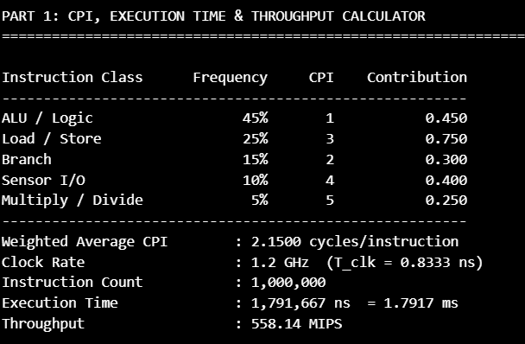
Figure 2: Script output — CPI, execution time, and throughput calculator (Section 1.4 verification)
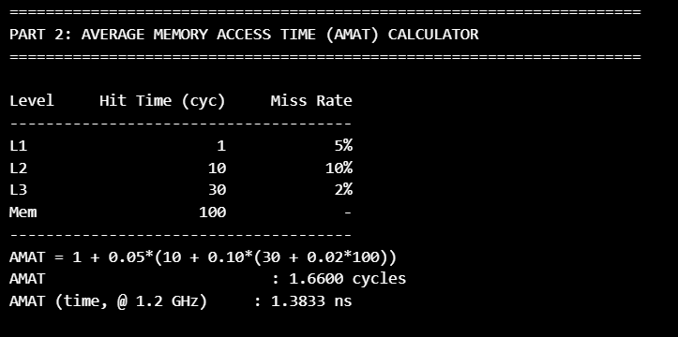
Figure 3: Script output — multi-level AMAT calculator (Section 3.2 verification)
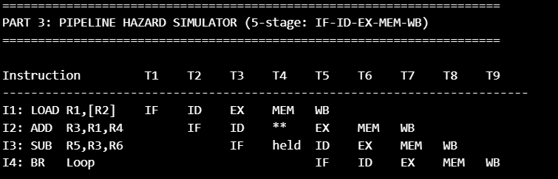
Figure 4: Script output — 5-stage pipeline hazard trace (Section 2.1 verification)
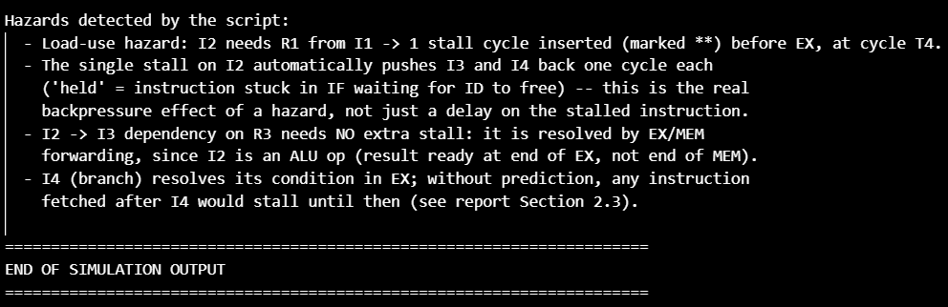
Figure 5: Script output — hazard-detection summary and simulation completion
Figure 6: Confirmation of script execution (run environment)
The script's output matches the hand-derived values exactly: weighted CPI = 2.1500, execution time ≈ 1.7917 ms, throughput ≈ 558.14 MIPS, and AMAT ≈ 1.6600 cycles. The pipeline simulator additionally confirms that the single load-use stall on I2 (marked ** at cycle T4) automatically delays I3 and I4 by one cycle each (marked 'held'), which is the correct backpressure behaviour of a real in-order pipeline and matches the hazard-mitigation discussion in Section 2.3.
Full source code for processor_simulator.py, along with this captured output, is included in the project's GitHub repository (see Deliverables Checklist).

5. Reflection: Design Decisions, SDG Relevance & Learning Outcomes (10 Marks)

5.1 Justification of Key Design Decisions
The design deliberately favours a moderate-complexity in-order/2-way-superscalar pipeline with SMT over a full out-of-order superscalar core. This trade-off was chosen because the target application — industrial sensor monitoring — has a fairly predictable, loop-dominated instruction stream with limited instruction-level parallelism, so the large area and power overhead of full OoO hardware (reservation stations, large reorder buffers) would not be repaid by a proportional performance gain. Similarly, the 3-level cache hierarchy was sized around the measured Load/Store frequency (25%) rather than a generic desktop profile, and MRAM was introduced specifically to solve the power-loss resilience requirement of an industrial controller, which a purely SRAM/DRAM/Flash system would not address as efficiently.

5.2 Connection to Sustainable Development Goals
SDG | How the Design Supports It
SDG 7 — Affordable and Clean Energy | DVFS, clock-gating, DRAM self-refresh, and a right-sized (not over-provisioned) pipeline and cache hierarchy reduce energy per operation, lowering the electrical load the monitoring system places on the plant's power system.
SDG 9 — Industry, Innovation and Infrastructure | The processor directly enables reliable, real-time industrial monitoring and control — core infrastructure for a smart-manufacturing facility — while the SMT and hazard-mitigation techniques represent applied innovation in processor micro-architecture for embedded industry use.
SDG 12 — Responsible Consumption and Production | Non-volatile MRAM state retention avoids re-running or discarding in-progress production data after power interruptions, and wear-aware NAND flash logging reduces premature hardware replacement — both cutting waste in the manufacturing process the processor monitors.

5.3 Challenges Encountered
- Balancing performance against the energy budget: several individually attractive techniques (full OoO execution, deep speculation, 4-way SMT) had to be scaled back once their power cost was weighed against the modest ILP available in the target workload.
- Reasoning about hazards precisely: constructing the pipeline trace (Section 2.1) required carefully tracking which register values were available in which cycle to correctly identify where forwarding was sufficient versus where a stall was unavoidable.
- Choosing representative benchmark figures: general-purpose benchmarks (e.g., SPEC) do not reflect a sensor-driven control workload, so an EEMBC/CoreMark-style reference had to be justified instead.

5.4 Learning Outcomes and Possible Improvements
This assignment reinforced how the CPI/clock-time/execution-time equations, hazard analysis, and the multi-level AMAT formula are not independent topics but a single connected design process: a decision in one layer (e.g., adding SMT) changes the assumptions in another (e.g., cache contention, hazard frequency). A possible improvement for a future iteration would be to validate the analytical figures in Section 4 against a cycle-accurate simulator run (e.g., gem5) with the exact instruction mix used here, and to explore adaptive DVFS policies that respond to real-time sensor load rather than fixed idle-period gating.

GitHub Repository Link: https://github.com/Naveen7-ai/CSA-1203

References
1. Hennessy, J. L., & Patterson, D. A. Computer Architecture: A Quantitative Approach.
2. Patterson, D. A., & Hennessy, J. L. Computer Organization and Design: The Hardware/Software Interface.
3. Course materials, CSA1203 – Computer Architecture.
4. United Nations Sustainable Development Goals — https://sdgs.un.org/goals

